Regular Admission Process For FE/DSE/ME/MBA

- Go to Google Browser and type college website name i.e(https://www.pvgcoet.ac.in/) and
Press Enter button.
- Open the College website then Click on ‘Compus Connect’ Menu .

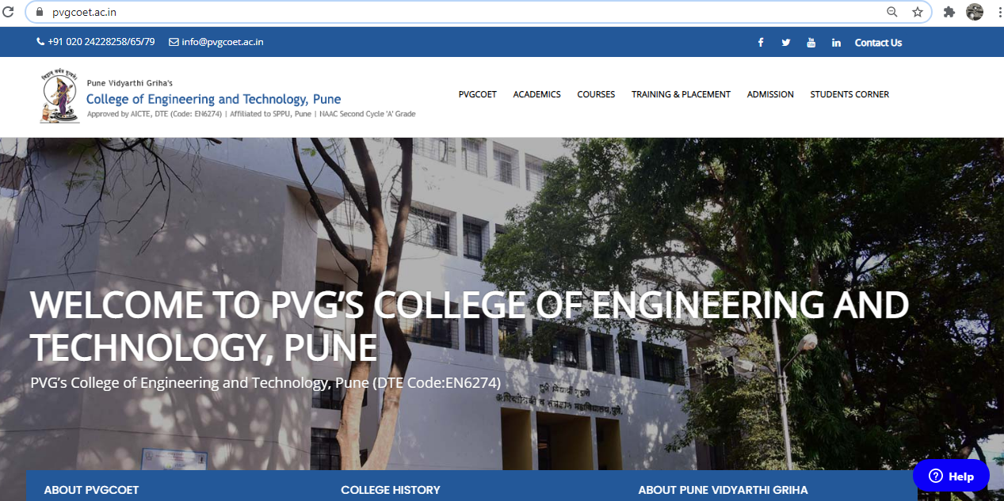

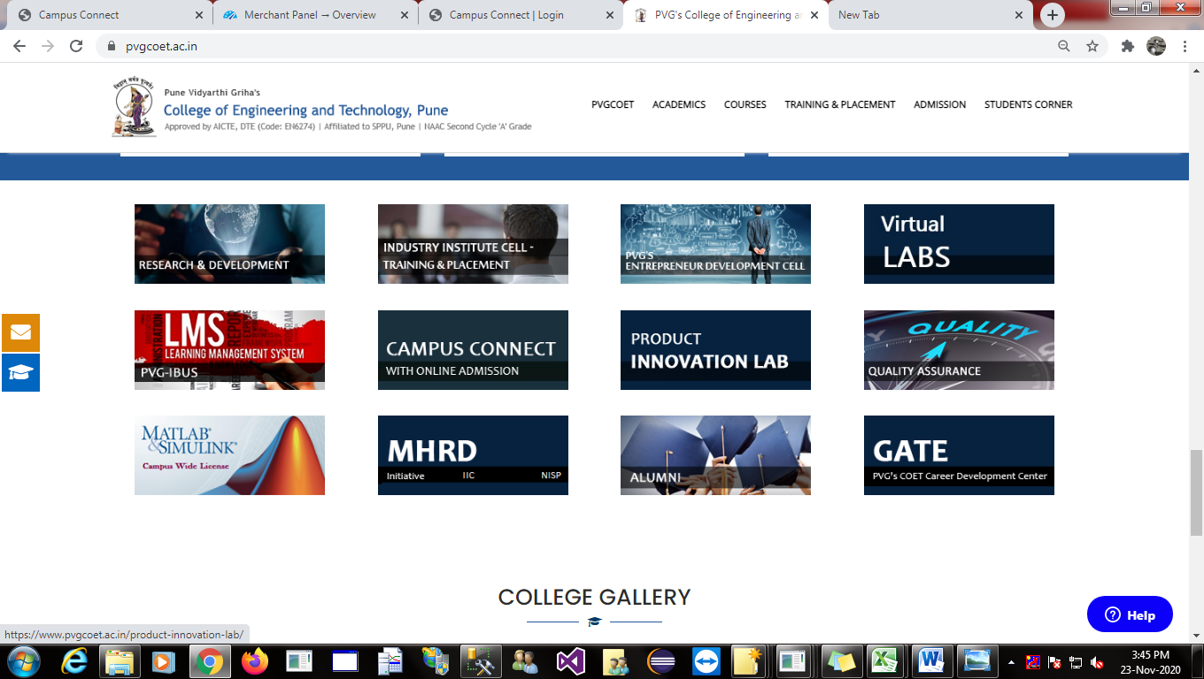
Click on Campus Connect for Online Admission

3.After click on Compus Connect Following Window Open
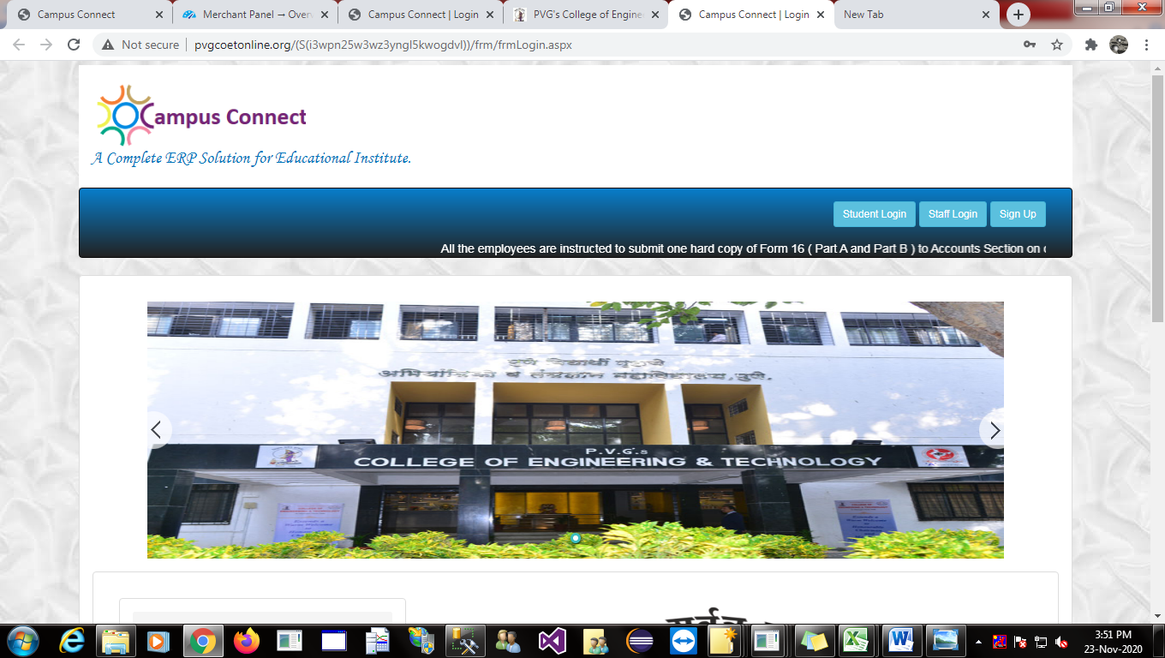
Click on Sign Up Menu for New Regular Admission

4.After click on Sign Up Following Form open

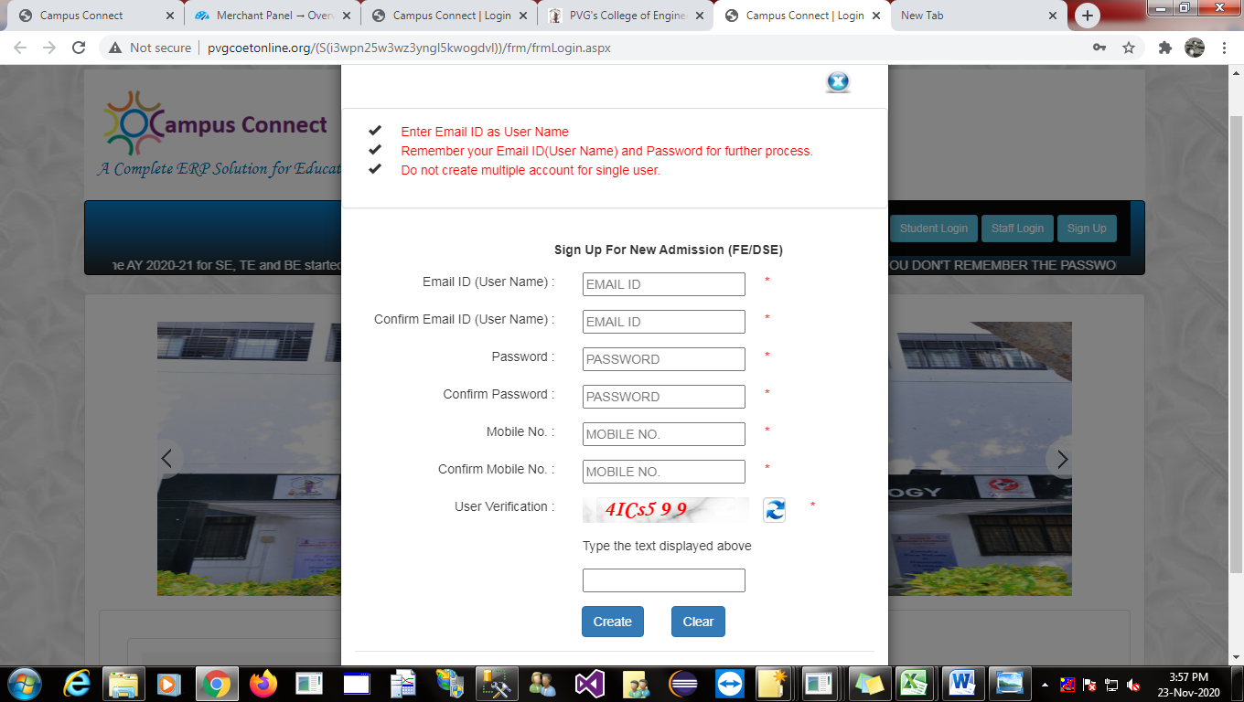

Fill the following Details for generating temparary Login ID and Password.
When Fill the all Details and click on Create button Display Successfully Created Message.

(Note : Remember Your Email ID (User Name) and Password for Further Process. )

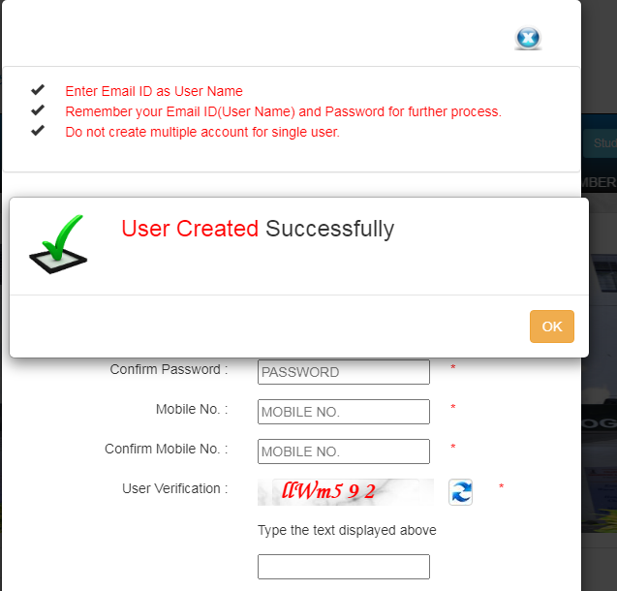

Then click On Ok .

5.Then click on Student Login
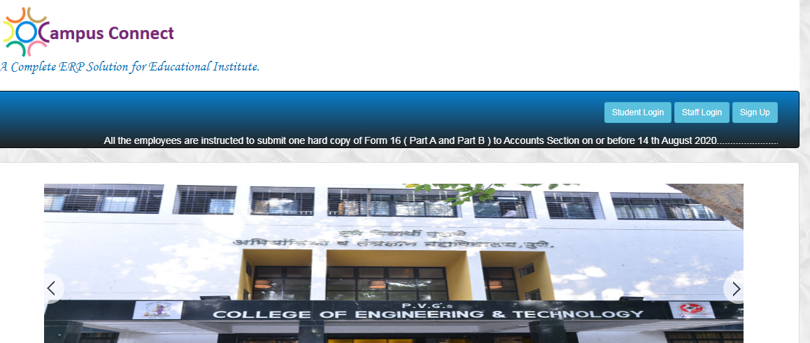
Then Click on Student Login

Following form Open

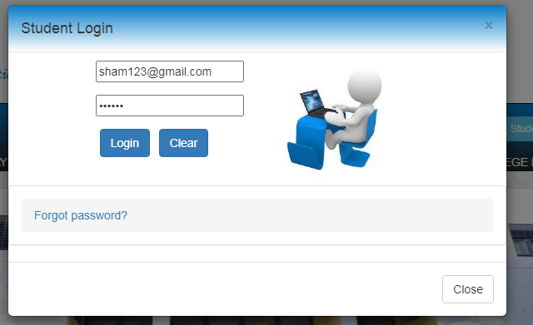
After filling User Name (Email Id) and Password click on Login Button

Fill the User Name (Email ID ) and Password for recent created And click on Login Button.

6.After click on Login Button following form opened.

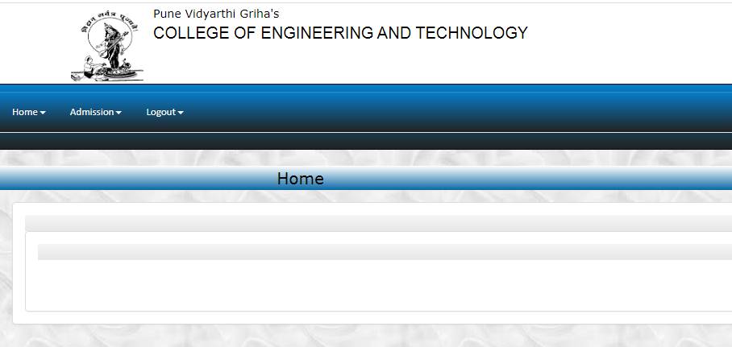

Then click on Admission Menu

Then Click On Regular Admission Form and fill the Student Details.

7.Fill all the Student Details Like (Student First Name, Student Last Name, Student Mobile No,Aadhar Card No,Class, Branch, fee category , Bank details , Parent Details etc)

Fill Student Details
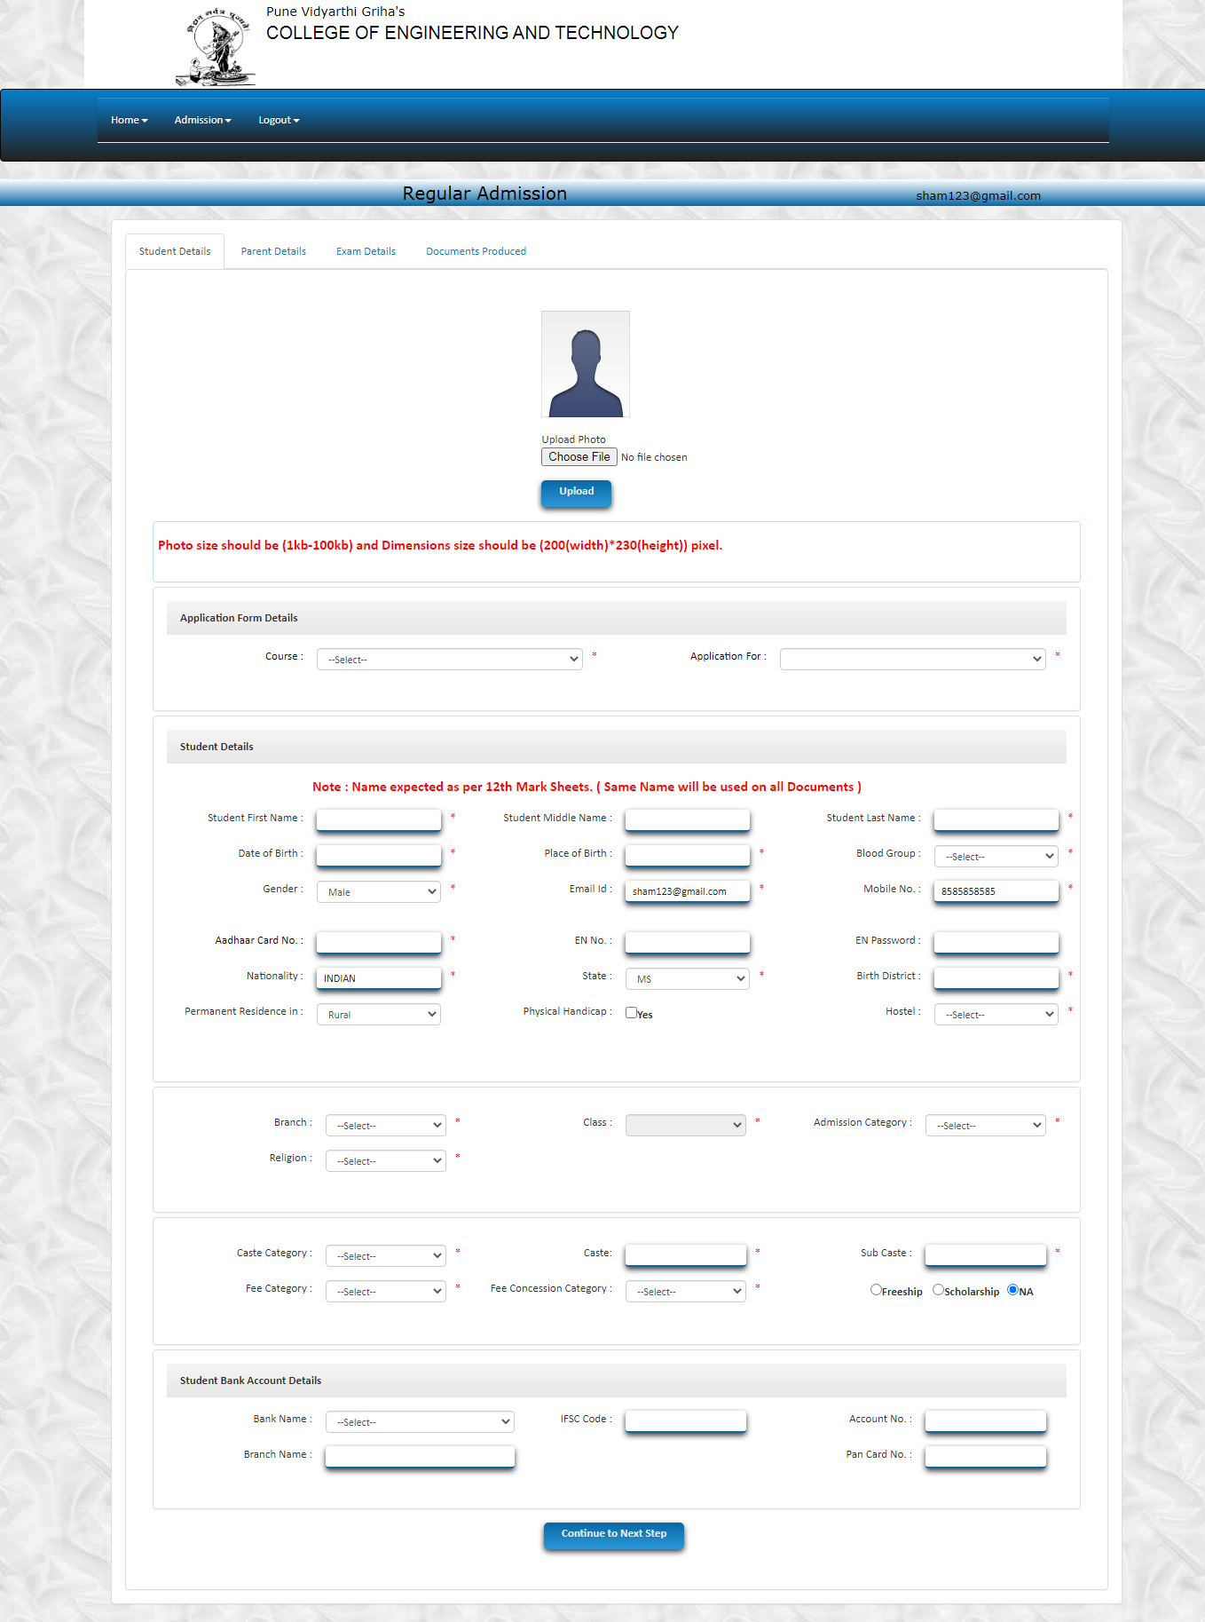

Fill Parent Details

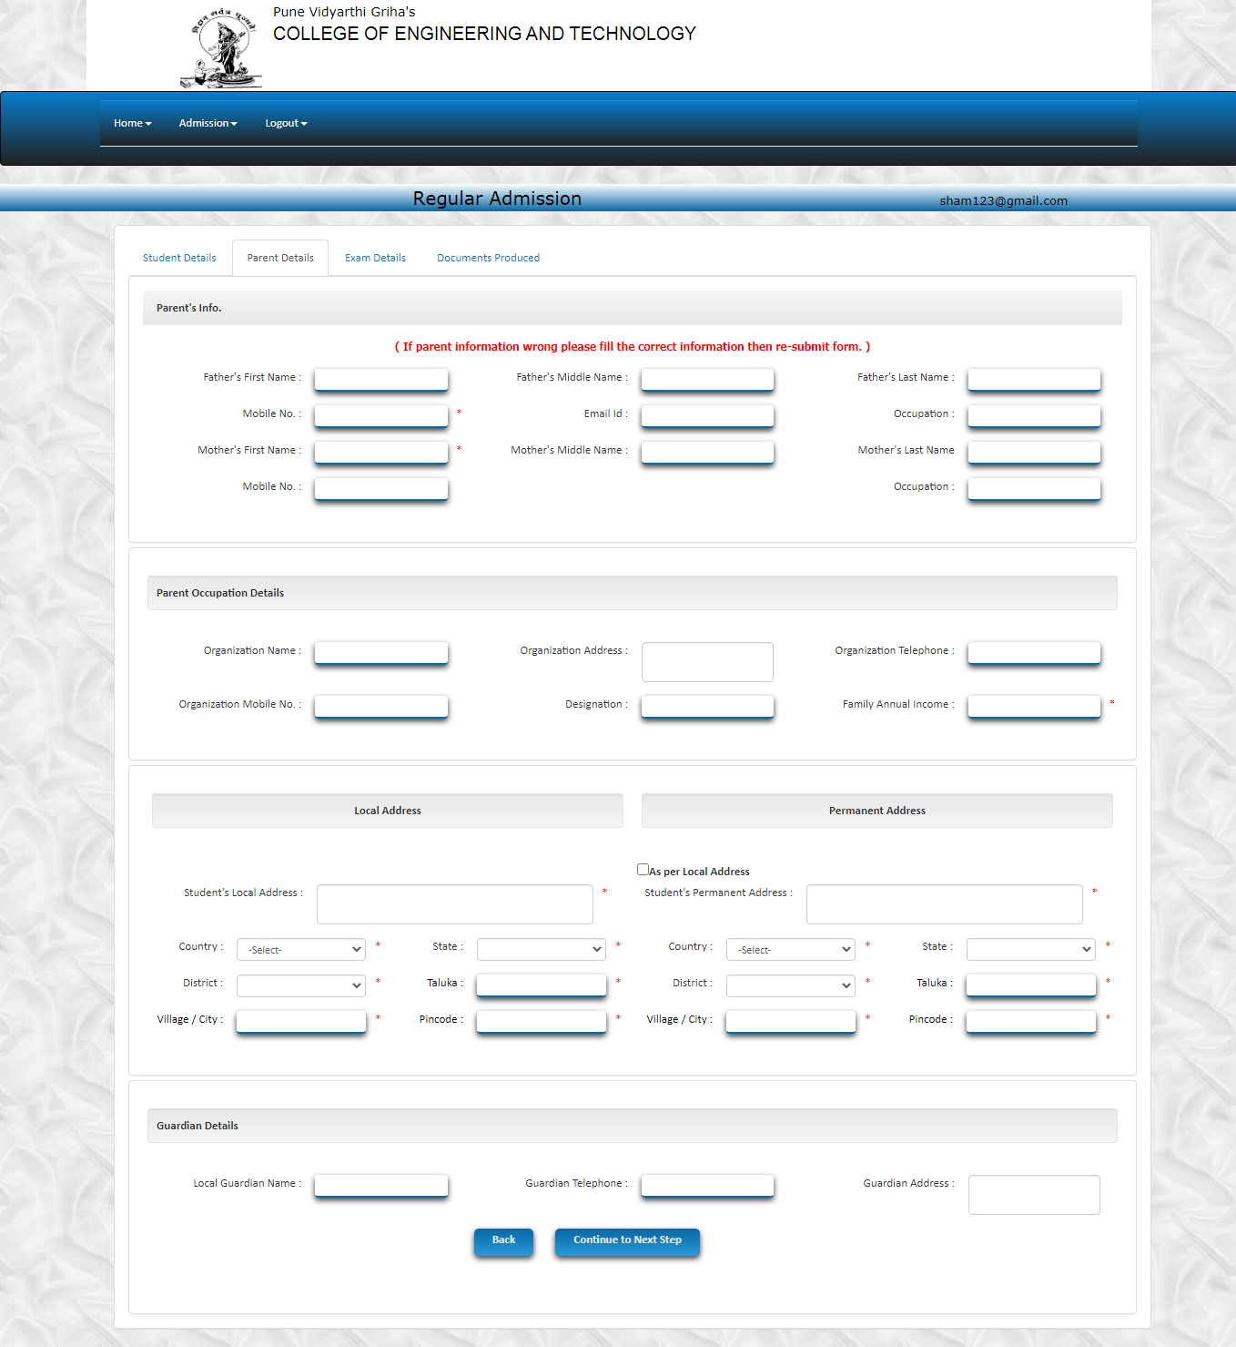

Fill Exam Details

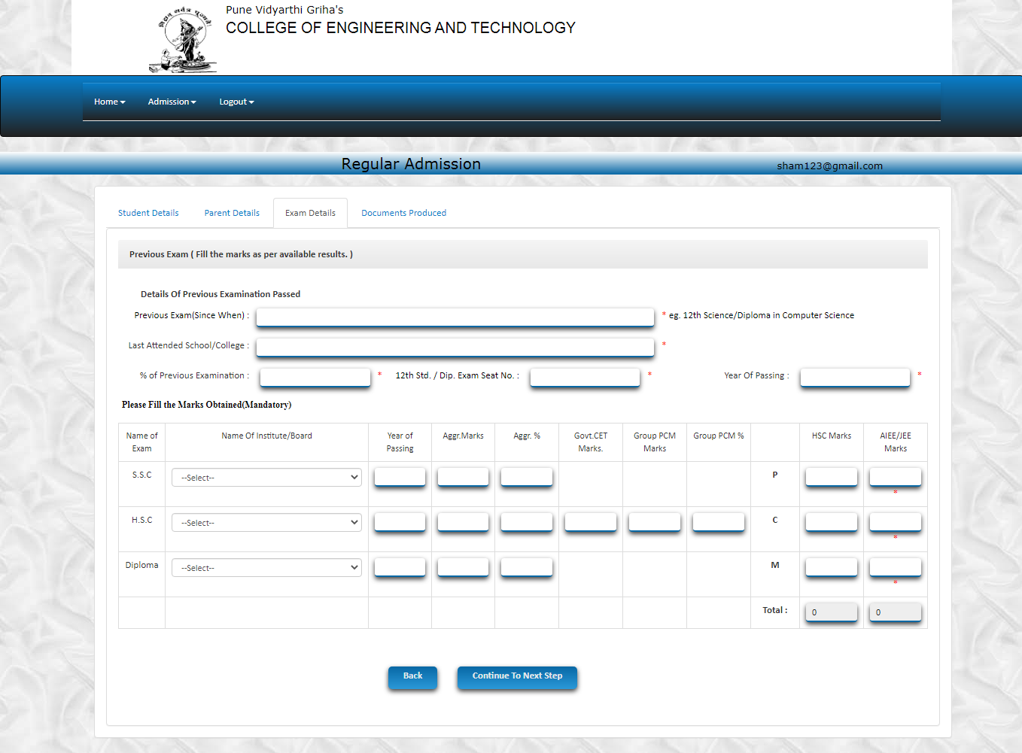

Upload All Applicable documents
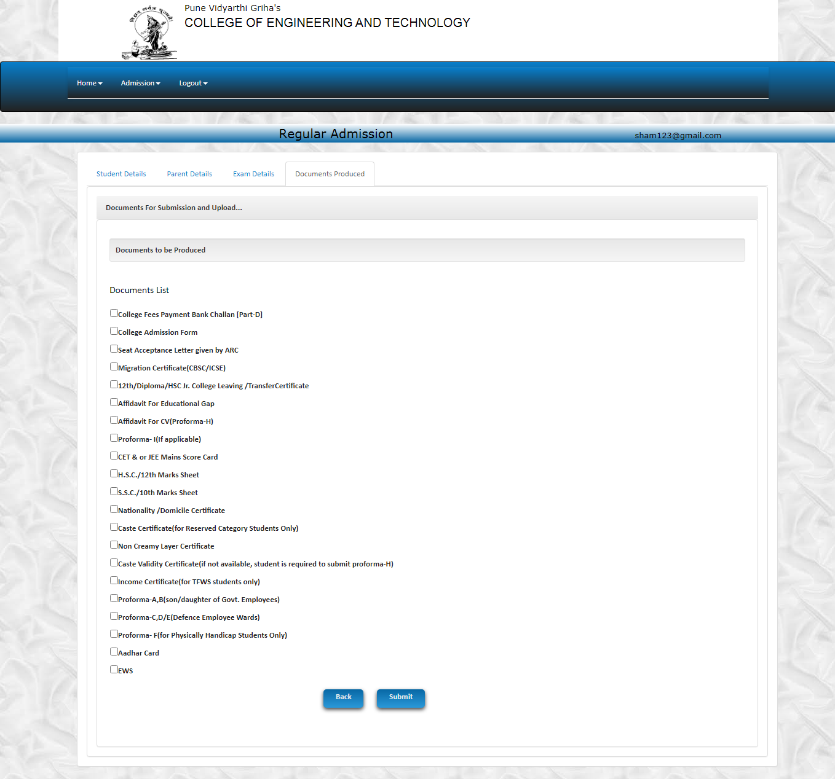
After Filling all the Details click on Submit Button they gives message Regular Admission form Seccuessfully Submitted.
(Note: In Admission Form Aadhar Card No And EN Number fill correct and remember for further Use.)

Take Print out of Admission form and attached xerox copy of all applicable documents.
Visit To the college with admission form and all original documents.

